Lab 8

# Question

In the paper “Structure and function of the global ocean microbiome,” Sunagawa et al. found that overall variability in a community (as measured by principle component analysis) was best explained by temperate. (Sunagawa et al., 2015)

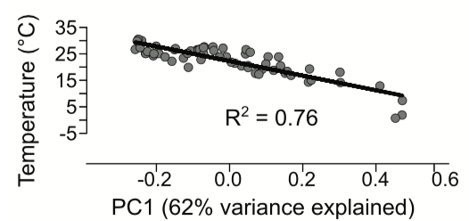

Item 1. The Figure 5a from the Sunagawa et al. paper.

Thus, one question might be**:** *is there is greater species richness and species diversity (as measured by Shannon-Weiner Index) in warmer water samples (15-30 °C) than in colder water samples (0-10 °C)?*

|  |  |  |  |  |  |
| --- | --- | --- | --- | --- | --- |
| Index (for this lab) | Run ID | Region | Sample details | Depth | Temp °C |
| 01_dcm_SernOcean | ERR599104 | Southern Ocean (near Antarctica) | deep chlorophyll maximum layer | 90 m | -0.78154 |
| 02_surface_SernOcean | ERR599090 | Southern Ocean (near Antarctica) | surface water layer | 5 m | 0.67108 |
| 03_meso_SPacific | ERR598999 | South Pacific (near the Marquesas) | mesopelagic zone | 600 m | 7.212238 |
| 04_surface_NAtlantic | ERR599078 | North Atlantic (off the coast of Portugal) | surface water layer | 5 m | 14.28065 |
| 05_dcm_SPacific | ERR598948 | South Pacific (near the Marquesas) | deep chlorophyll maximum layer | 115 m | 24.69625 |
| 06_surface_SPacific | ERR598992 | South Pacific (near the Marquesas) | surface water layer | 5 m | 26.54413 |